CS-384 Introduction to Data Science
CCP Project Report
Section: A



Submitted By:
Syed Shayan Arshad
2023-CS-625

Submitted To:
Mam. Alina Munir
Dated: 28th Dec 2025

Department of Computer Science
University of Engineering and Technology Lahore, New Campus
Analysis and Prediction of Air Quality Index (AQI) Using Machine Learning Models
Abstract
Air pollution is a major global environmental and public health issue. It is mainly caused by particulate matter (PM2.5 and PM10), harmful gases such as NO₂, SO₂, CO, and O₃, and different meteorological factors. This project analyses a global air quality dataset containing 10,000 records collected from major cities around the world.
The study includes data preprocessing and Air Quality Index (AQI) calculation using EPA-standard breakpoints, exploratory data analysis (EDA) to examine distributions and relationships, predictive modeling for AQI classification using multiple machine learning algorithms, and interpretation of results with recommendations for environmental improvement.
The results show a very strong correlation between PM2.5 and AQI (correlation ≈ 0.97), indicating that particulate matter is the most influential factor affecting air quality. Classification models such as Support Vector Machine (SVM) and Naive Bayes achieve high accuracy of approximately 95%. The Random Forest regression model predicts AQI values with high precision, achieving an R² value of around 0.988. Additionally, K-Means clustering combined with Principal Component Analysis (PCA) reveals that the data can be grouped into two major pollution levels.
Data Preprocessing (Feature Engineering)
The Global Air Quality Dataset consists of 10,000 records from cities worldwide and includes major air pollutants such as PM2.5, PM10, NO₂, SO₂, CO, and O₃, along with meteorological variables like temperature, humidity, and wind speed. A key limitation of the dataset was the absence of an Air Quality Index (AQI) column.
To address this, AQI values were calculated using EPA standard breakpoints. AQI values were computed for individual pollutants, and the maximum value was selected as the final AQI and also for classification tasks AQI_Category column was created and encoded using Label Encoding. Additionally, the Date column was converted into datetime format, and a new Month feature was extracted for analysis. As a result, the total number of columns increased from 12 to 15.
Handling Missing Values and Outlier Detection
After feature engineering, the dataset was examined for missing values. As no missing values were found therefore, no imputation or interpolation techniques were required. This confirms that the dataset was complete and ready for analysis.
Outlier detection was then performed using boxplots. The analysis indicated that all values were within acceptable ranges, and no significant outliers were detected. Consequently, no outlier treatment was necessary. This fulfills requirement of outlier detection and handling.
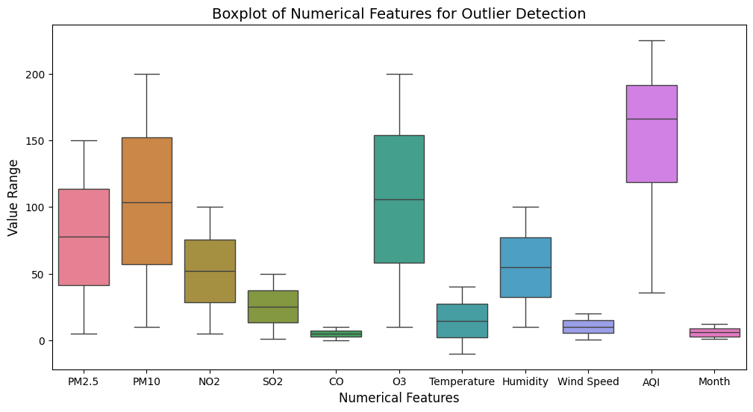
Exploratory Data Analysis (EDA)
Univariate Analysis
Univariate analysis was conducted to examine the distribution of individual variables in the dataset. Count plots were used to analyze the frequency distribution of cities and countries, while histograms were plotted for all the numerical features.
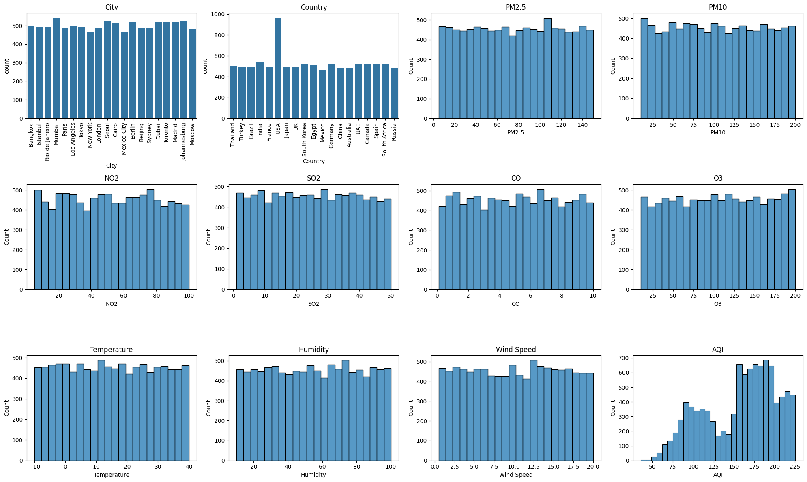
Bivariate Analysis
Bivariate analysis was performed to examine the relationship between AQI and individual pollutants. Scatter plots were created between AQI and PM2.5, PM10, NO₂, SO₂, CO, O₃, temperature, humidity, and wind speed.
The results indicate a strong positive relationship between AQI and particulate matter (PM2.5 and PM10). In contrast, gaseous pollutants and meteorological variables show no clear or consistent relationship with AQI.
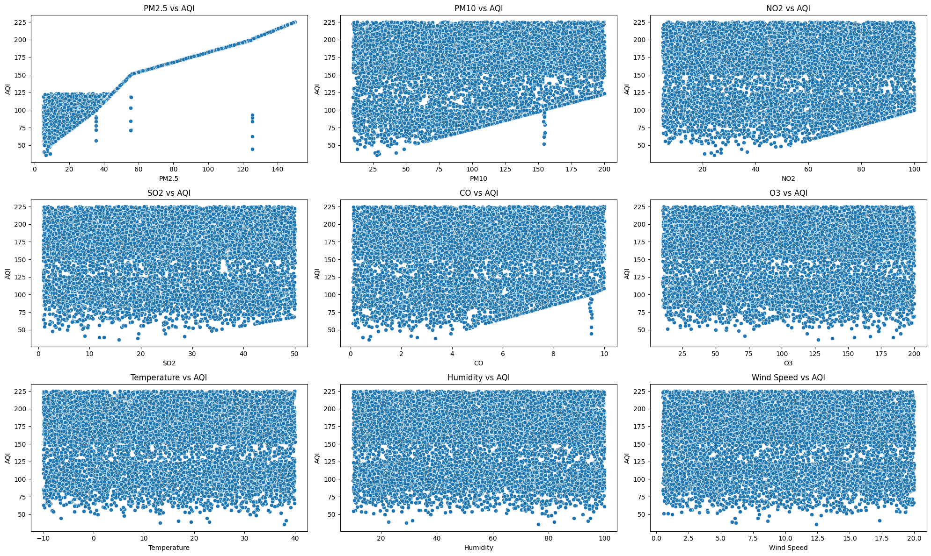
Correlation Analysis
Correlation analysis was conducted using a heatmap to quantify relationships among numerical variables. The correlation matrix confirms that PM2.5 and PM10 have the strongest positive correlation with AQI.
Meteorological factors such as temperature, humidity, and wind speed show relatively weak correlations with AQI. This suggests that pollutant concentrations, particularly particulate matter, play a more dominant role in determining air quality than weather-related factors.
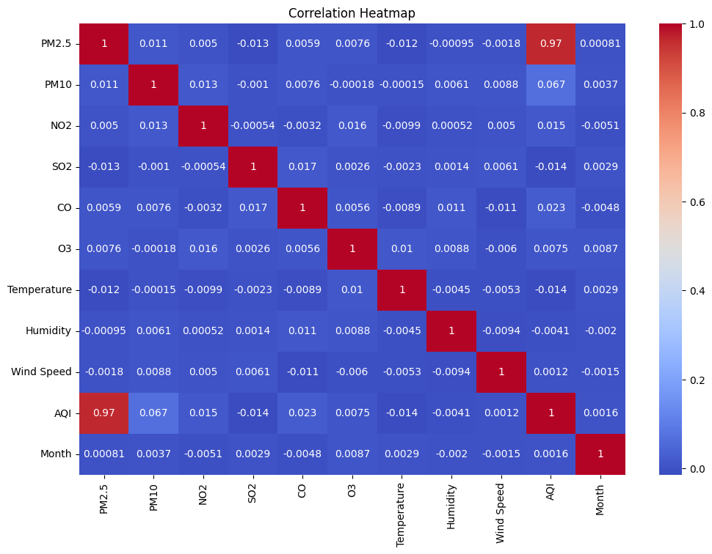
Comparative Analysis
Comparative analysis was used to evaluate air quality across different countries and cities. A bar chart was created to identify the top 10 countries with the highest average AQI values. Additionally, AQI category distributions were compared across countries to assess differences in pollution severity levels.
The results highlight noticeable variations in air quality among countries, with some regions consistently experiencing higher pollution level
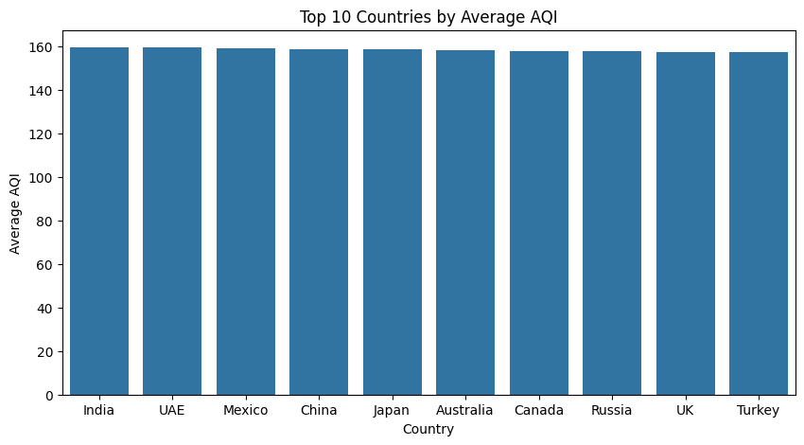
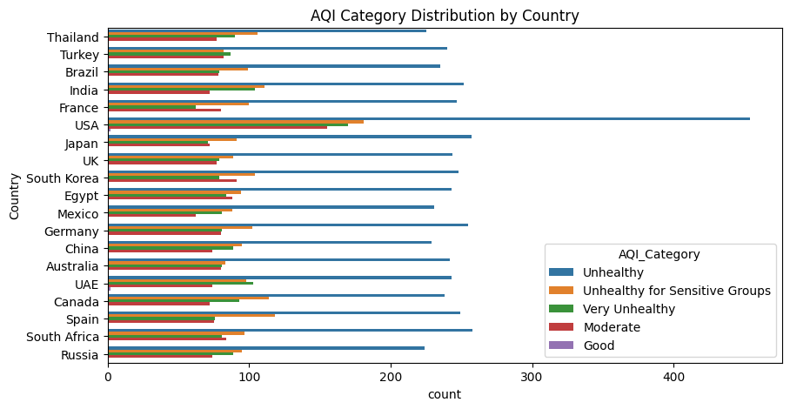
Identification of Cycles and Temporal Patterns
Temporal analysis was conducted to identify seasonal and cyclical trends in air quality. Monthly average AQI values were visualized using a line plot. The analysis shows that June and September have the lowest average AQI compared to other months.
Furthermore, a heatmap was used to examine monthly AQI patterns across different countries. The results indicate fluctuations in AQI levels across months and regions, confirming the presence of seasonal and cyclical pollution patterns.
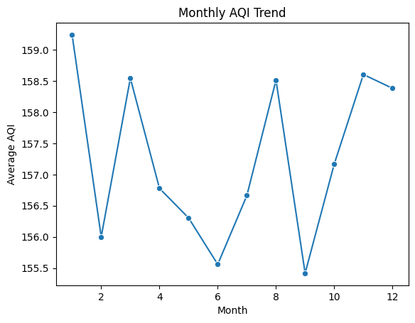
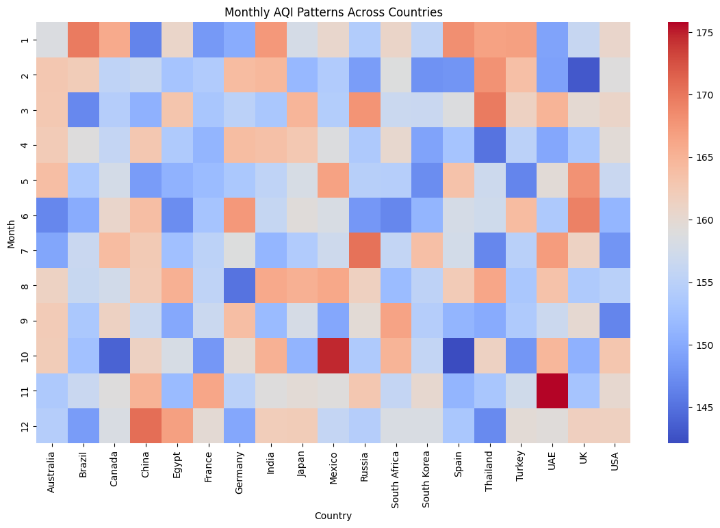
Feature Selection, Encoding, Scaling, and Data Splitting
Before training the machine learning models, irrelevant and non-numerical columns such as City, Country, Date, AQI, and Month were removed to ensure that only meaningful numerical features were used for model training. The target variable, AQI_Category, was converted into numerical form using Label Encoding, as shown below:
AQI Category | Number of Records | Label Encoding
Good | 13 | 0
Moderate | 1547 | 1
Unhealthy | 4814 | 2
Unhealthy for Sensitive Groups | 1947 | 3
Very Unhealthy | 1679 | 4
The dataset was then divided into input features (X) and the target variable (y). An 80:20 train–test split was applied, with 80% of the data used for training and 20% for testing. Stratification was applied on the target variable to preserve class distribution, and a random state of 42 was used to ensure reproducibility.
After splitting the data, numerical features were standardized using StandardScaler. The scaler was fitted only on the training data and then applied to both training and testing sets to ensure that all variables are on a similar scale, which improves the performance of many machine learning algorithms.
Model Building & Prediction
Multiple machine learning models were applied to predict air quality and analyze pollution patterns. Classification, regression, and clustering approaches were used to provide a comprehensive analysis of the dataset.
Classification Models for AQI Category Prediction
Four classification algorithms were implemented to predict AQI_Category:
- K-Nearest Neighbors (KNN)
- Support Vector Machine (SVM)
- Naive Bayes
- Logistic Regression
All models were trained using scaled features and evaluated on the test dataset using accuracy, precision, recall, F1-score, and confusion matrices.
K-Nearest Neighbors (KNN) Model
The KNN classifier was trained with k = 5. The model achieved an overall accuracy of 75%. The model performed well for majority classes but showed weaker performance for minority classes due to class imbalance.
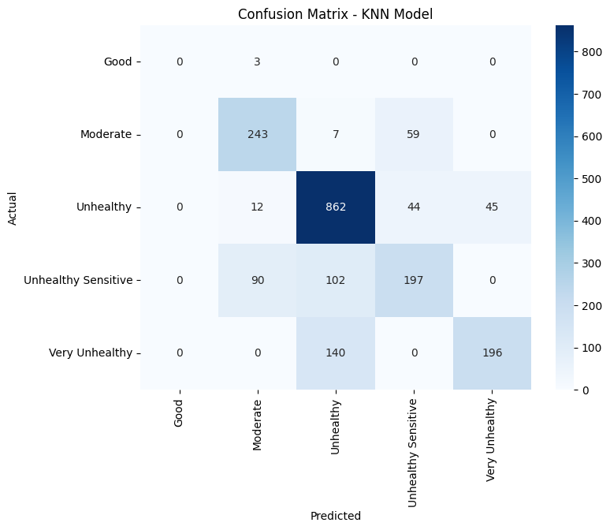
Support Vector Machine (SVM) Model
The SVM classifier achieved excellent results with an overall accuracy of 95%. It demonstrated high precision and recall across most AQI categories, particularly for Moderate, Unhealthy, and Very Unhealthy classes.
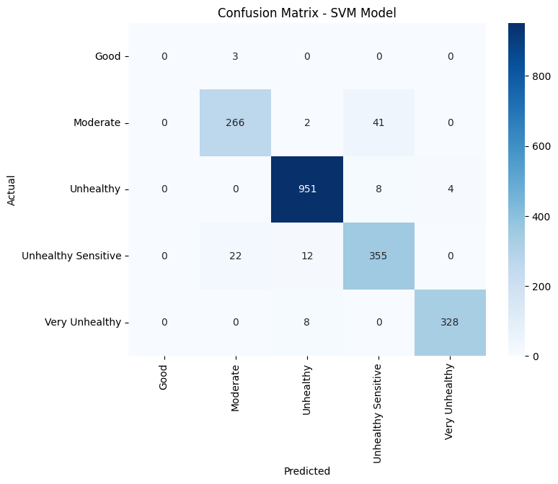
Naive Bayes Model
The Naive Bayes classifier also performed strongly, achieving an accuracy of 95%. Despite its simplicity, the model showed robust performance, especially for dominant AQI categories.
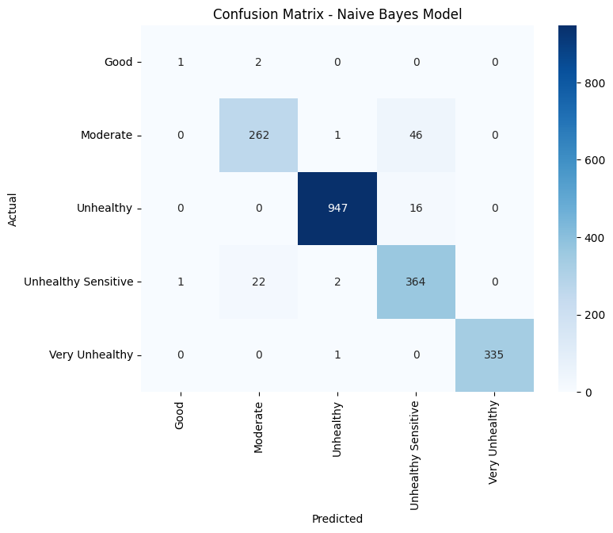
Logistic Regression Model
Logistic Regression achieved an overall accuracy of 93%. The model provided stable and consistent results across most AQI categories, with strong performance for higher pollution levels.
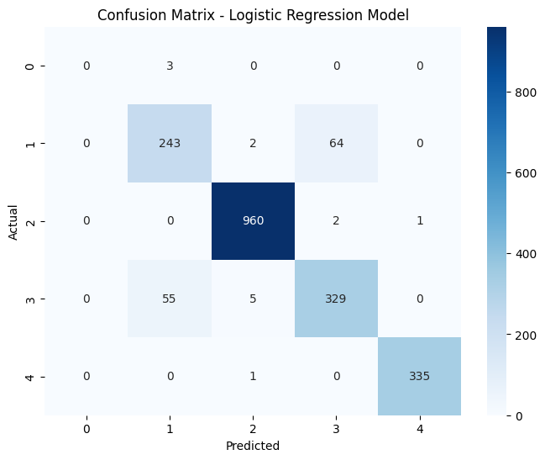
Classification Model Comparison (Summary)
Among all classification models, SVM and Naive Bayes emerged as the best-performing classifiers, while KNN showed relatively lower performance due to sensitivity to class imbalance.
Model | Accuracy | Weighted Precision | Weighted Recall | Weighted F1-Score
K-Nearest Neighbors | 0.75 | 0.75 | 0.75 | 0.74
Support Vector Machine (SVM) | 0.95 | 0.95 | 0.94 | 0.94
Naive Bayes | 0.95 | 0.96 | 0.95 | 0.95
Logistic Regression | 0.93 | 0.93 | 0.93 | 0.93

Handling Class Imbalance Using SMOTE
The AQI_Category variable exhibited significant class imbalance, particularly for minority classes such as Good. To address this issue, the Synthetic Minority Over-sampling Technique (SMOTE) was applied to the training dataset.
SMOTE generates synthetic samples for underrepresented classes, enabling models to learn more balanced decision boundaries.
Model | Accuracy | Weighted Precision | Weighted Recall | Weighted F1-Score
K-Nearest Neighbors | 0.71 | 0.74 | 0.71 | 0.72
Support Vector Machine (SVM) | 0.94 | 0.95 | 0.94 | 0.94
Naive Bayes | 0.91 | 0.93 | 0.91 | 0.92
Logistic Regression | 0.88 | 0.91 | 0.88 | 0.89
Although overall accuracy slightly decreased after applying SMOTE, the models produced more balanced and generalized predictions. The reduction in bias toward majority classes makes SMOTE-based models more suitable for real-world AQI classification tasks. Overall, SVM consistently outperformed other classifiers in both scenarios.
Regression Models for AQI Value Prediction
In addition to classification, regression models were used to predict the continuous AQI value. The following regression models were implemented:
- Linear Regression
- Decision Tree Regressor
- Random Forest Regressor
Model performance was evaluated using R-squared (R²), Mean Absolute Error (MAE), and Mean Squared Error (MSE).
Linear Regression
The Linear Regression model achieved an R² score of 0.94, indicating a strong linear relationship between pollutant variables and AQI.
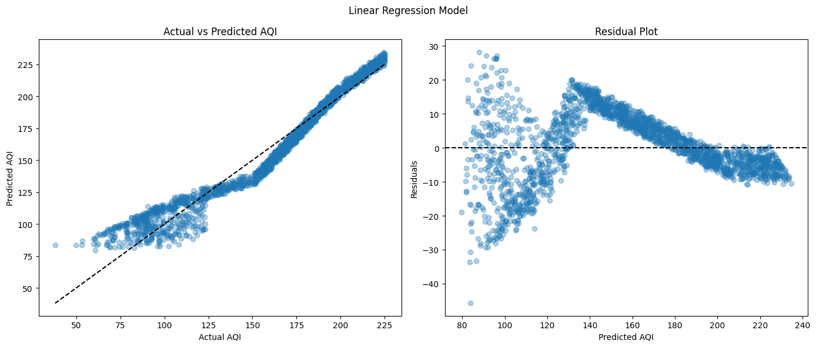
Decision Tree Regressor
The Decision Tree Regressor improved prediction performance with an R² score of 0.97. This model was more effective in capturing non-linear relationships between pollutants and AQI.
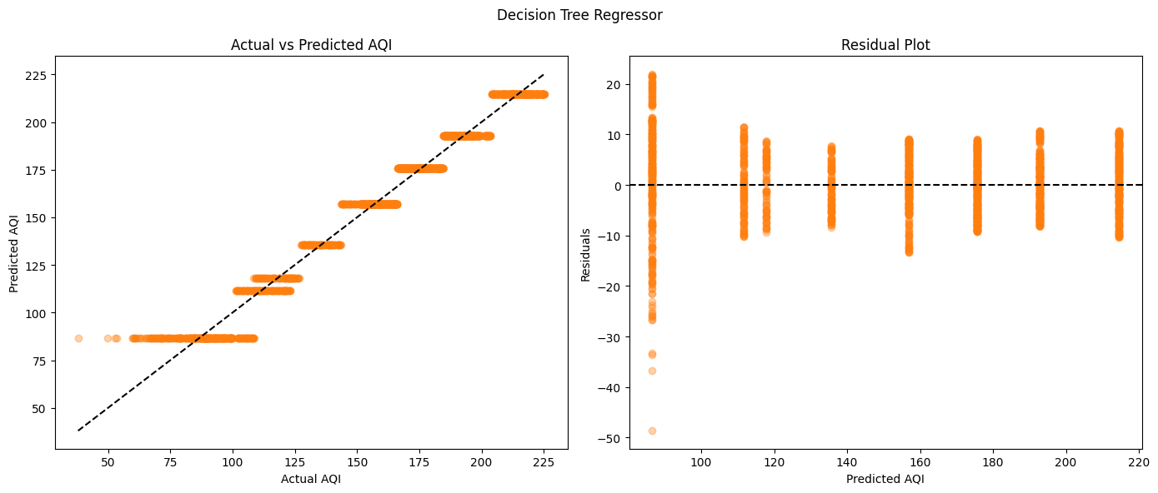
Random Forest Regressor
The Random Forest Regressor produced the best results, achieving an R² score of 0.98 along with the lowest MAE and MSE values. This indicates highly accurate AQI predictions and strong generalization performance.
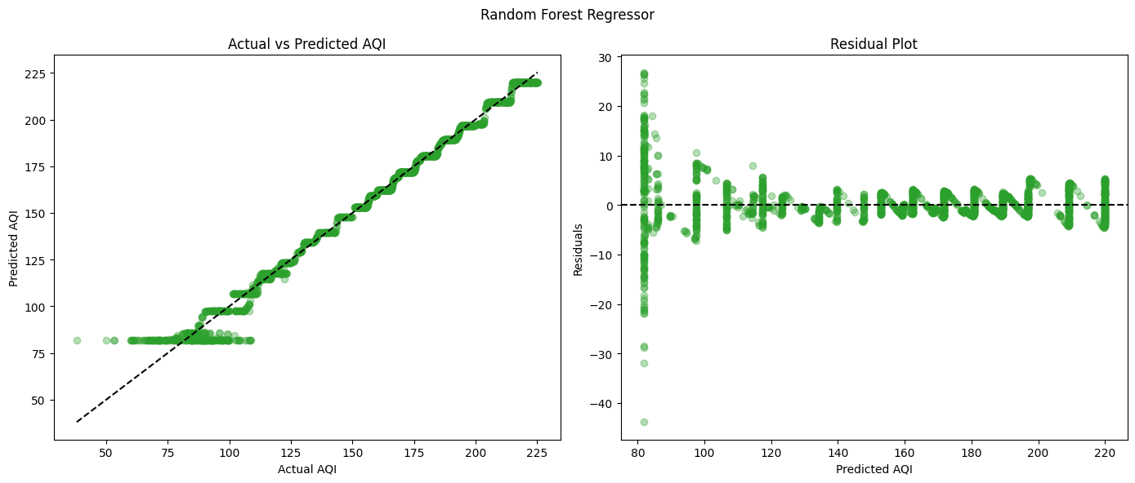
Regression Model Performance Summary
Overall, the Random Forest Regressor outperformed other regression models and was selected as the most accurate model for AQI value prediction.
Model | R² Score | Mean Absolute Error (MAE) | Mean Squared Error (MSE)
Linear Regression | 0.947 | 7.99 | 99.72
Decision Tree | 0.973 | 5.57 | 51.30
Random Forest | 0.988 | 2.85 | 22.69

Clustering Analysis (Unsupervised Learning)
To identify hidden patterns in air quality data, unsupervised learning techniques were applied. Initially, the dataset included the following 10 features:
PM2.5, PM10, NO₂, SO₂, CO, O₃, AQI, wind speed, humidity, and temperature.
To reduce dimensionality and select the most important features, Principal Component Analysis (PCA) was applied to reduce dimensionality and identify the most influential features. Feature importance was evaluated using PCA loadings, where higher absolute values indicate stronger contributions to principal components.
Based on PCA loadings, the following six features were selected as the most influential:
- PM2.5
- PM10
- NO₂
- CO
- O₃
- AQI
These features contributed most strongly to the first two principal components (PC1 and PC2), which together explained approximately 49.9% of the total variance. Dimensionality reduction improved both clustering performance and interpretability.
PCA Features Importance
Features | PC1 | PC2
PM2.5 | 0.704672 | -0.049471
NO2 | 0.015371 | 0.680913
CO | 0.021674 | 0.176383
O3 | 0.011285 | 0.561815
AQI | 0.706605 | -0.015082
PM10 | 0.057564 | 0.432361
K-Mean Clustering
K-Means clustering was applied using the selected PCA-based features to identify distinct air quality patterns.
Elbow Method
The Elbow Method was used to determine the optimal number of clusters. The elbow point in the WCSS plot indicated an optimal value of k = 2.
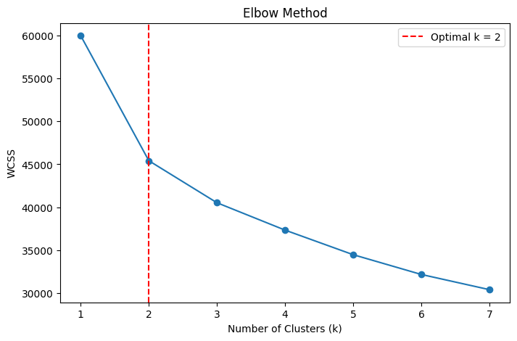
Silhouette Analysis
Silhouette analysis was conducted to evaluate cluster quality. The average silhouette score for k = 2 was 0.2228, indicating reasonable separation between the clusters.
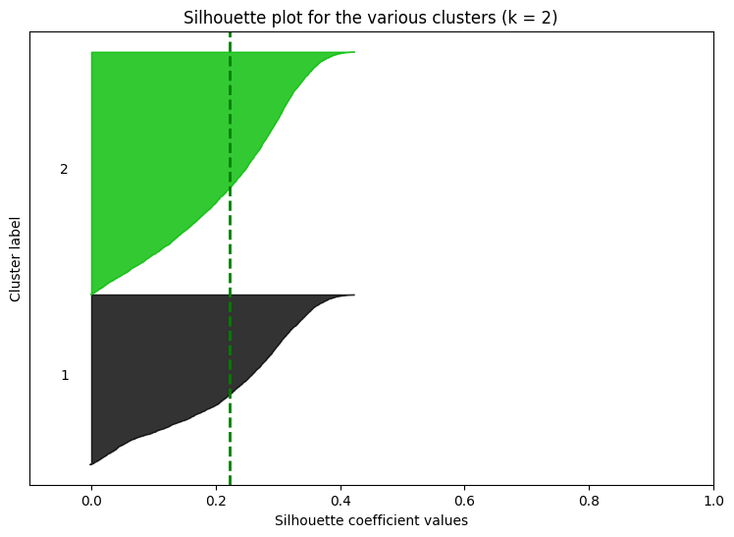
Cluster visualization using scatter plots clearly showed two distinct clusters, representing different pollution levels across cities.
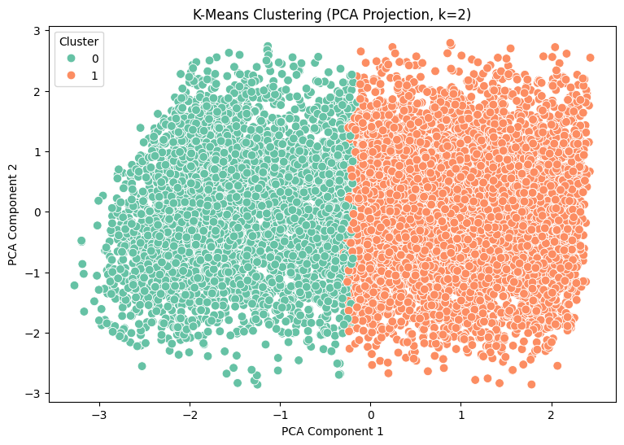
Overall Findings from Models
- SVM and Naive Bayes showed the best performance for AQI category classification
- Random Forest Regressor achieved the highest accuracy for continuous AQI prediction
- PCA-based feature selection reduced model complexity while preserving important information
- Clustering analysis revealed distinct pollution patterns across different cities
Model Interpretation and Recommendations
Model Interpretation
The outcomes of the machine learning analysis indicate that particulate matter (PM2.5 and PM10) is the most influential factor affecting both AQI values and AQI categories. This conclusion is supported by correlation results, PCA feature importance, and the strong predictive performance of models that heavily rely on particulate features.
Gaseous pollutants such as NO₂, CO, and O₃ also play an important role in air quality degradation; however, their overall impact is comparatively lower than that of particulate matter.
In terms of classification, Support Vector Machine (SVM) and Naive Bayes achieved the most reliable results, showing high accuracy along with balanced precision and recall. For continuous AQI prediction, the Random Forest Regressor outperformed other regression models by achieving the highest R² score and the lowest prediction errors. This highlights its ability to capture complex and non-linear relationships between pollutants and air quality.
Impact of Air Pollution on Human Health
Exposure to elevated levels of air pollutants poses serious risks to human health. Fine particulate matter (PM2.5 and PM10) can penetrate deep into the respiratory system and bloodstream, increasing the risk of asthma, chronic respiratory diseases, cardiovascular problems, and reduced lung function.
Nitrogen dioxide (NO₂) contributes to airway inflammation and raises susceptibility to respiratory infections. Carbon monoxide (CO) limits the blood’s ability to carry oxygen, which may result in headaches, dizziness, and heart-related issues. Ozone (O₃) exposure can cause breathing discomfort, chest pain, throat irritation, and lung inflammation.
The high proportion of observations classified as Unhealthy and Very Unhealthy AQI levels in the dataset indicates significant long-term health risks, particularly for vulnerable populations such as children, elderly individuals, and people with existing medical conditions.
Recommendations for Environmental Improvement
Based on the findings of this study, the following strategies are recommended to improve air quality:
- Transition to cleaner energy sources by reducing dependence on fossil fuels and increasing the use of renewable energy in power generation and industrial operations.
- Introduce emission-based taxation to discourage excessive pollution from vehicles and industrial units while encouraging cleaner technologies.
- Strengthen urban planning policies by controlling unplanned urban expansion and reducing pollution hotspots through better traffic flow management.
- Improve air quality forecasting systems using machine learning models to provide early warnings and preventive actions during high-pollution periods.
- Encourage community-level participation, such as local monitoring programs and citizen reporting systems, to promote shared responsibility for environmental protection.
Conclusion of Interpretation
The interpretation of results indicates that PM2.5 and PM10 are the primary factors affecting air quality, as supported by correlation analysis, PCA, and model performance. Gaseous pollutants such as NO₂, CO, and O₃ contribute to pollution but have a comparatively smaller impact.
Among the models, SVM and Naive Bayes performed best for AQI classification, while the Random Forest Regressor provided the most accurate AQI predictions. Overall, this study demonstrates that machine learning and data-driven approaches can effectively assess air quality and identify key pollutants, supporting policymakers in developing targeted strategies to control pollution and protect public health.

